



ATHBY 2021

Human Biology Year 12

Marking Guide

Assessment Type: Science Inquiry

Student name: __________________________ Date: __________ Score: _________ **/15**

**Assessment Type: Science Inquiry Week 1   
Question 1**Thyroxine is a hormone the thyroid gland secretes into the bloodstream. Once in the bloodstream, thyroxine travels to the organs such as the liver and kidneys. Thyroxine plays a crucial role in heart and digestive function, metabolism, brain development, bone health, and muscle control. It affects almost all of the body's systems, which means proper thyroxine levels are vital for health.

An investigation was carried out to study the effects of administering the hormone thyroxine to patients with a malfunction of the thyroid gland. Two groups of patients were treated; Group A received hormone and Group B received a placebo. The basal metabolic rate (BMR) of the patients in the two groups was taken over a period of three weeks.

All patients in both groups began with a similar BMR which averaged 30% below normal level. After three weeks, patients in Group A had raised their BMR on average to 1% below normal level. Group B still had an average of 30% below normal level.

a) Propose a hypothesis for this investigation. (1)  
 Thyroxine raises BMR.

b) List two variables that would need to be controlled to ensure that this investigation was reliable. (2)

* same method of administration/
* same amount of thyroxine and placebo/
* same age range/
* similar genetic factor/
* similar nutritional status/
* same time of administration of thyroxine and placebo/

c) Define ‘placebo’. (1)

substance without active ingredient/no effects/no physiological effects/ no pharmacological effects

d) Why are placebo usually administered in scientific experiments? (1)

act as a control/ for comparison with the experimental group

reduces the effects of psychological influences/effects of the results

**Question 2**

Water balance is regulated by antidiuretic hormone (ADH). ADH regulates osmotic pressure of body fluids by causing the kidneys to increase water reabsorption.

Use the table below to complete the following questions.

|  |  |  |
| --- | --- | --- |
| Time (mins) | Levels of ADH in the bloodstream | Rate of urine production in the kidney (mL/min) |
| 0 | 7.5 | 2.1 |
| 2 | 7.5 | 2.1 |
| 4 | 7.0 | 2.1 |
| 6 | 17.0 | 1.5 |
| 8 | 22.0 | 1.3 |
| 10 | 7.0 | 1.5 |
| 12 | 7.5 | 2.1 |
| 14 | 7.5 | 2.1 |

a) Plot these results on grid paper. (5)

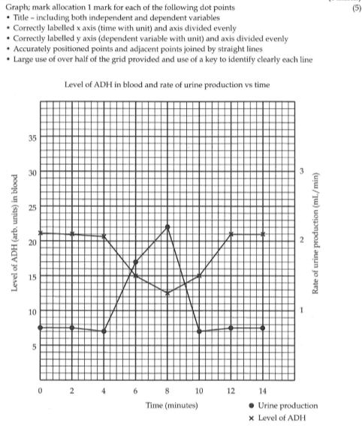

b) Identify the independent and dependent variables in this experiment. (2)

independent variable: levels of ADH

Dependent variable: rate of urine production mL/min

c) From the graph, determine the level of ADH in the blood stream after 7 minutes. (1)

in range 19 – 20 arbitrary unit

d) Describe the relationship between ADH level and the rate of urine production in the kidney. (2)

High level of ADH increases water reabsorption in the kidneys therefore reduces urine production.